BS6202 Assignment 3

Yaoding Chen | 14-15 Aug 2021

Introduction
According to the central dogma of molecular biology, genes encoded in DNAs are transcribed into RNA and subsequently encode amino acids that encode protein. Thus, gene transcription plays a major role in biology functions and changes in gene transcription are often related to disease (Kalia & Gupta, 2005), which attach great importance to discovery of differential expressed genes (DEG). However, DEGs derived from different studies may significantly differ, as reported by Zhang et al. (2009). Considerate decisions should be made to ensure reproducibility and robustness of the DEG studies (Fang et al., 2012). Here we aim to calculate the percentages of overlapping genes of 6 datasets. We want to ask whether the overlapping is quite small even for the most significantly differentially expressed genes and hope to explore approaches to increase reproducibility of DEG results.

Materials & Methods
Most of the datasets have been summarised in the table below (Belorkar & Wong, 2016), except Mary et al and Allen et al studying disease subtypes.
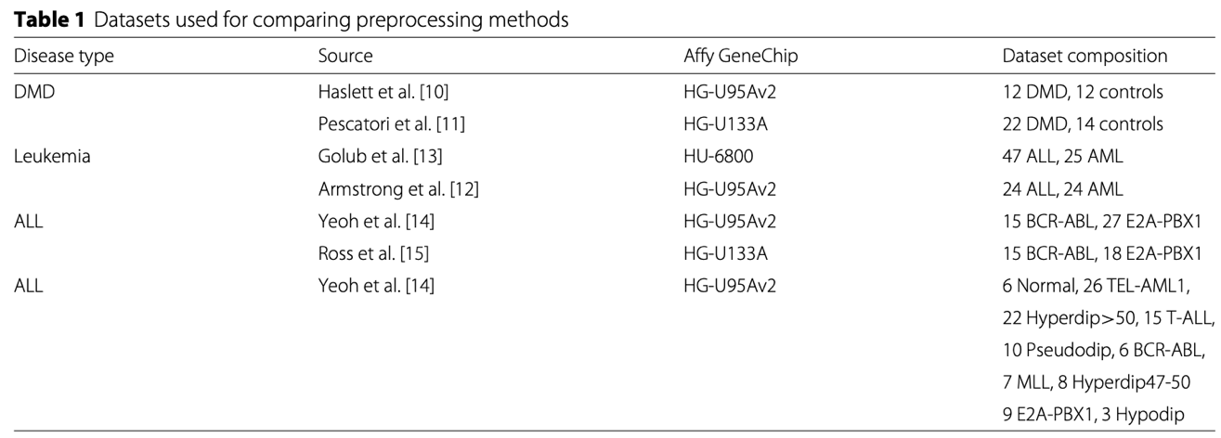
Then we need to acquire a list as provided by Belorkar & Wong (2016), as is shown on the right. According to Zhang et al. (2009), to calculate the percentage of overlapping genes (PoGs), following steps needs to be taken:
- Step 1: use CDF files provided by Carter et al. (2005) and the “altcdfenvs” R package provided by Gautier et al. (2004) to remap probe IDs to cDNA clones. Yet, this steps may be performed ultimately.
- Step 2: use log2 function to transform and normalise data. Especially, COPA is used to display the most profound overexpression in different cohorts, which can be achieved with the “copa” R package.
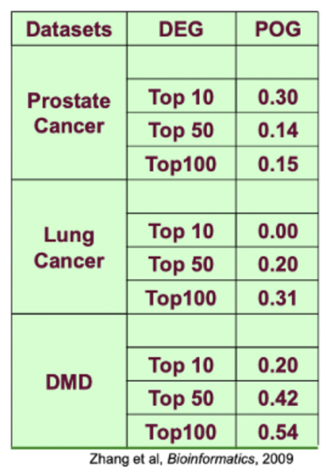
- Step 3: use Pearson’s correlation distribution to compare paired genes lists, which produces Pearson’s r as an indicator of effect size and p value as an indicator of statistical significance. Besides, to control false discovery rate (FDR), Zhang et al (2009) used a method described by Zhang (2007).
- Step 4: rank the genes according to their p values adjusted according to Benjamini & Hochberg (1995) and keep the top 30%, 15%, 10% DEG lists, and then compare the gene lists acquired in Step 4 and calculate PoGs accordingly.
However, for some reason, I found the CDF file by Carter et al. (2005) not importable. Therefore, I skip the step and later use R packages like AbsIDconvert (Mohammad et al., 2012), yet it is currently not compatible with my computer for some reason. Therefore, we used an online tool named g:Profiler (Raudvere et al., 2019).
Also, to simplify the question, FDR is not controlled as described above but rather use an R function called “p.adjust” and I will not use COPA for normalisation but rather we will first use t-test to address the question. Since Pearson’s correlation also uses t statistics, to simplify the question, we can just do a t-test to get a p-value and a Pearson’s correlation test to get a correlation coefficient.
Lastly, it is sometimes the case that one probe is translated to more than one gene IDs, or more than one probe detecting the same genes, according to g:Profiler and other methods. We then treat the additional gene IDs equally, giving them the same p-value as the probe, although this might exaggerate the significance. The process has been taken manually due to a failure to install related R packages using macOS running on M1 chip.

Results

Question 1&2: low consistency in DEGs across studies
To answer Question 1, first we will not consider directionality of DEGs, and only use the p-values from t-test results derived from untransformed and un-normalised data. The results are shown below:
Dataset | All |  |  | Leuk |  |  | DMD
DEG | Top10 | Top50 | Top100 | Top10 | Top50 | Top100 | Top10 | Top50 | Top100
PoG | 4.0% | 2.0% | 1.0% | 17.6% | 10.2% | 10.2% | 5.9% | 5.8% | 5.9%
Overall, our results show low consistency of DEGs across different studies, which is as the Question 2 has pointed out, and best-case is no more than 17.6% PoG in Leuk, which shows high versatility of DEG lists and is consistent with the discovery of Zhang et al. (2009). However, the current work does not involve normalisation or transformation, which needs to be improved further to reduce batch effect and to make the results more robust. Also, it should be noticed that t test may not be well-suited into the situation here, since many of the groups do not have normal distribution; thus, other methods may be used.

Question 3: misuses & limitations of statistical tests
Question 3 asks whether inconsistency is due to the nature/limitation of the statistical test. However, it should be acknowledged that there is no one-size-fit-all statistical method (Vindras et al., 2012). As all tests or models are not perfect, one should always carefully understand and choose statistical tests for a variety of cases to avoid misuse. Specifically in our case, as illustrated by Zhang et al. (2009), minor changes in FDR could lead to change of p-value, which may give different results, which again stresses the importance of choosing proper statistical methods and warns the risk of overly depending on any single statistical parameters like p-value. Specifically, as summarised by Wasserstein & Lazar (2016),
- P-values can indicate how incompatible the data are with a specified statistical model.
- P-values do not measure the probability that the studied hypothesis is true, or the probability that the data were produced by random chance alone.
- Scientific conclusions and business or policy decisions should not be based only on whether a p-value passes a specific threshold.
- Proper inference requires full reporting and transparency.
- A p-value, or statistical significance, does not measure the size of an effect or the importance of a result.
- By itself, a p-value does not provide a good measure of evidence regarding a model or hypothesis.”
In a typical statistical analysis, we focus on the associated statistic (e.g., t or z), which has been widely reported and often misused, and the estimation for the amplitude of the effect itself (e.g., a β value from regression analysis or GLM), which is often missed. Oftentimes, p-value could be mistakenly thought to be manifest effect size, which and exaggerate effect size (Halsey et al., 2015).
Furthermore, it should be noted that there is a clear difference between statistical significance and practical significance, which means a statistically significant result could be meaningless if the effect size difference is so small that it cannot make sense in real life (Chen et al., 2017).
Lastly, under a null hypothesis, p-value is not the probability of obtaining the data under the current study, but rather a conditional probability, which means that statistically significant results do not mean non-existence of an effect (Chen et al., 2017). Therefore, it is good to define a meaningful effect size range a priori, which helps to determine the sample size and to achieve enough statistical power of the study. More importantly, it is crucial to report effect size in a study, as the liability of the test result, as indicated by p-value, does not replace the effect estimation itself (Chen et al., 2017).

Question 4: improving normalisation or transformation for DEG analysis
As for Question 4, there are things to do to improve normalisation or transformation, which is omitted in our previous discussion. However, note that all data seems to have undergone log2 transformation as the gene expression profiles contains negative values, except in two DMD datasets. So we may perform log2 transformation for DMD datasets and then calculate COPA scores in all datasets. This is an example of median scaling described by Belorkar & Wong (2016), whereas the authors propose what is called Gene Fuzzy Score (GFS), which is defined by the following equation,
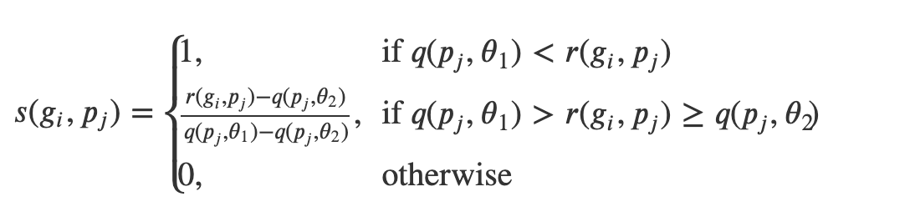
where two quantile thresholds – θ1 and θ2 are assigned to fuzzify different gene scores in each patient. Since small expression levels are often associated with higher variance, the GFS nullify the small expression level under θ1 to reduce noise. This approach is proved to excel other pre-processing methods. Thus, this is a possible improvement to the datasets we have.

References
Belorkar, A., & Wong, L. (2016). GFS: fuzzy preprocessing for effective gene expression analysis. BMC Bioinformatics, 17(Suppl 17), 540. https://doi.org/10.1186/s12859-016-1327-8
Benjamini, Y., & Hochberg, Y. (1995). Controlling the false discovery rate: a practical and powerful approach to multiple testing. Journal of the Royal Statistical Society: Series B (Methodological), 57(1), 289–300.
Carter, S. L., Eklund, A. C., Mecham, B. H., Kohane, I. S., & Szallasi, Z. (2005). Redefinition of Affymetrix probe sets by sequence overlap with cDNA microarray probes reduces cross-platform inconsistencies in cancer-associated gene expression measurements. BMC Bioinformatics, 6(1), 107. https://doi.org/10.1186/1471-2105-6-107
Chen, G., Taylor, P. A., & Cox, R. W. (2017). Is the statistic value all we should care about in neuroimaging? NeuroImage, 147, 952–959. https://doi.org/10.1016/j.neuroimage.2016.09.066
Fang, Z., Martin, J., & Wang, Z. (2012). Statistical methods for identifying differentially expressed genes in RNA-Seq experiments. Cell & Bioscience, 2(1), 26. https://doi.org/10.1186/2045-3701-2-26
Gautier, L., Møller, M., Friis-Hansen, L., & Knudsen, S. (2004). Alternative mapping of probes to genes for Affymetrix chips. BMC Bioinformatics, 5(1), 111. https://doi.org/10.1186/1471-2105-5-111
Halsey, L. G., Curran-Everett, D., Vowler, S. L., & Drummond, G. B. (2015). The fickle P value generates irreproducible results. Nature Methods, 12(3), 179–185. https://doi.org/10.1038/nmeth.3288
Kalia, A., & Gupta, R. P. (2005). Proteomics: A paradigm shift. In Critical Reviews in Biotechnology (Vol. 25, Issue 4, pp. 173–198). Taylor & Francis. https://doi.org/10.1080/07388550500365102
Mohammad, F., Flight, R. M., Harrison, B. J., Petruska, J. C., & Rouchka, E. C. (2012). AbsIDconvert: An absolute approach for converting genetic identifiers at different granularities. BMC Bioinformatics, 13(1), 229. https://doi.org/10.1186/1471-2105-13-229
Raudvere, U., Kolberg, L., Kuzmin, I., Arak, T., Adler, P., Peterson, H., & Vilo, J. (2019). g: Profiler: a web server for functional enrichment analysis and conversions of gene lists (2019 update). Nucleic Acids Research, 47(W1), W191–W198.
Vindras, P., Desmurget, M., & Baraduc, P. (2012). When One Size Does Not Fit All: A Simple Statistical Method to Deal with Across-Individual Variations of Effects. PLOS ONE, 7(6), e39059. https://doi.org/10.1371/journal.pone.0039059
Wasserstein, R. L., & Lazar, N. A. (2016). The ASA statement on p-values: context, process, and purpose. Taylor & Francis.
Zhang, M., Zhang, L., Zou, J., Yao, C., Xiao, H., Liu, Q., Wang, J., Wang, D., Wang, C., & Guo, Z. (2009). Evaluating reproducibility of differential expression discoveries in microarray studies by considering correlated molecular changes. Bioinformatics, 25(13), 1662–1668. https://doi.org/10.1093/BIOINFORMATICS/BTP295
Zhang, S. (2007). A comprehensive evaluation of SAM, the SAM R-package and a simple modification to improve its performance. BMC Bioinformatics, 8(1), 230. https://doi.org/10.1186/1471-2105-8-230

